Multiple choice section

|  |  |  |  |  |  |  |  |  |  |  |
| --- | --- | --- | --- | --- | --- | --- | --- | --- | --- | --- |
| Question | 1 | 2 | 3 | 4 | 5 | 6 | 7 | 8 | 9 | 10 |
| Answer | D | B | C | A | D | A | D | D | B | D |

Question 1 [1.1]

D

7 –  = -3

- = -10

-5x = -60

x = 12

Question 2 [1.1]

B

5(a – 2) = 3(a + 2)

5a – 10 = 3a + 6

2a = 16

a = 8

Question 3 [1.2]

C

4x – 2y = 8

4x – 8 = 2y

y = 2x – 4

∴ gradient = 2

Question 4 [1.2]

A

Lines parallel to the y-axis (vertical lines) have an undefined gradient.

Question 5 [1.3]

D

y = -x + 5

3y = -2x + 15

2x + 3y = 15

Question 6 [1.4]

A

The line with equation  has the gradient of -2.

The line with equation  can be expressed as  where both lines have the same gradient of -2. These lines are parallel.

Question 7 [1.4]

D

The line with equation  has a gradient of 2. A line that is perpendicular to this line has a gradient of  as .

Question 8 [1.5]

D



Question 9 [1.5]

B

 < 1

2 – 5x < 8

-5x < 6

x > -1.2

So x = -1.5 is not a solution.

Question 10 [1.6]

D

Substitute y = -2x + 10 into   
2y + 3x = 14.

2(-2x + 10) + 3x = 14

-4x + 20 + 3x = 14

-x + 20 = 14

-x = -6

x = 6

Substitute x = 6 into y = -2x + 10,

y = -2 × 6 + 10

= -2

x = 6, y = -2

Multiple-choice total marks: 10

Short answer section

Question 11 11 marks

(a) A *linear relationship* exists between two variables when the graph of the relationship is a straight line.

(b) A linear relationship is described by a *linear equation*.

(c) Linear equations can be solved by applying *inverse operations* to both sides of the equation.

(d) The *gradient* of a line is a measure of its steepness, which can be evaluated by evaluating the fraction *rise over run*.

(e) The general equation of a straight line is y = mx + b where m is the gradient of the line and b is the *y-intercept* of the line.

(f) Lines that are *parallel* have the same gradients.

(g) Lines that are *perpendicular* meet each other at an angle of 90°.

(h) A linear equation has *one* solution and a linear *inequality* has a range of solutions according to the inequality.

Question 12 4 marks [1.3, 1.4]

Answers may vary.

Lines that are parallel to the line  have gradients of 2 and lines that are perpendicular to that line have gradients of . The equations and graphs of the lines need to have these gradients and intercept the y-axis at the position consistent with each equation.

Question 13 3 marks [1.1]

  
4x – 5 = 35  
4x = 40  
x = 10

Question 14 4 marks [1.1]

  
5(4x + 2) + 3(2x – 1) = 30,   
so 20x + 10 + 6x – 3 = 30.

26x + 7 = 30, so 26x = 23.

x = 

Question 15 2 marks [1.2]



Question 16 2 marks [1.3]

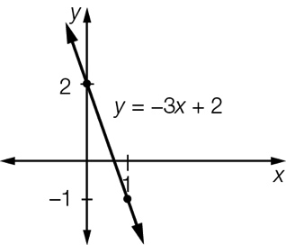

Question 17 4 marks [1.4]

(a) The equation  can be expressed as . As the lines  and  have the same gradients then they are parallel.

(b) The equation  can be expressed as  so that it's gradient is , and the equation  can be expressed as  so that it's gradient is -2. As the product of their gradients is -1 () then the lines are perpendicular.

Question 18 4 marks [1.5]

(a) 3x + 1 ≥16   
3x ≥ 15  
x ≥ 5

(b) 5x – 3 < 7  
5x < 10  
x < 2

Question 19 4 marks [1.6]

2x – 3(3x – 10) = 16

-7x + 30 = 16

7x = 14

x = 2

y = 3(2) – 10 = -4

Solution: (2, -4)

Question 20 4 marks [1.6]

4x + 6y = 32

15x – 6y = 6 add

19x = 38, so x = 2

Hence y = 4

Solution: (2, 4)

Question 21 3 marks [1.1]





5x – 4 = 5 × 5 – 4

= 25 – 4

= 21

The dimensions are: two sides of 4 cm and one side of 21 cm.   
These lengths are not possible for a real triangle.

Short answer total:_________/45

Extended answer section

Question 22 6 marks [1.2, 1.3, 1.4]

(a) 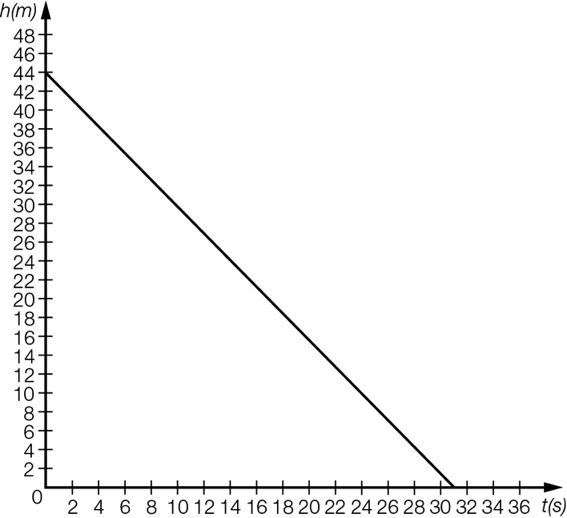

(b) Gradient = , hence rate of descent is 

(c) 

(d) The elevator is 44 metres high.

Question 23 10 marks [1.2, 1.3, 1.4]

(a), (b) (i), (c) (i) 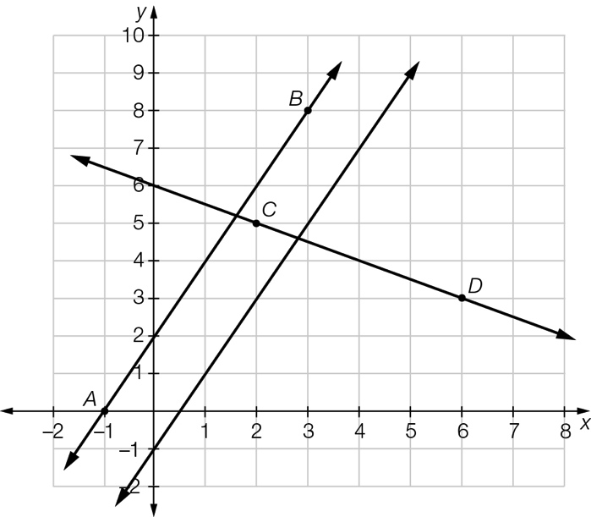

(b) (i) Equation of the line AB is 

(ii) As the gradient of both lines is 2 then they are parallel.

(c) (i) Equation of the line CD is 

(ii) As the product of the gradient of the lines is -1  then they are perpendicular.

Question 24 4 marks [1.6]

(a)  where b is the number of buns.

(b)



The baker can make up to 208 more buns.

Question 25 5 marks [1.5]

Let a and b be the cost in cents of each apple and banana, respectively.

2a + 3b = 80 [1]

a + 5b = 75 [2]

2a + 10b = 150 [2]×2

Subtract 2×[2]– [1]:

7b = 70, so b = 10, hence a = 25.

Each apple cost 25 cents and each banana cost 10 cents.

Extended answer total:______/25

TOTAL test results: _____ / 80